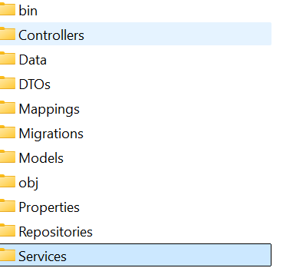

Create a script to create subfolders – Data, DTOs, Mappings, Models, Services, Repositories

"Data", "DTOs", "Mappings", "Models", "Services", "Repositories" | ForEach-Object { New-Item -Path $_ -ItemType Directory -Force }

